**CS 132 Computer Science I**

**HOP03 – Numeric Operators and Routines**

12/31/2019 Developed by Kim Nguyen

10/18/2020 Revised by Kim Nguyen

Center for Information Assurance (CIAE) @City University of Seattle (CityU)



**Before You Start**

* Version numbers may not match with the most current version at the time of writing. If given the option to choose between stable release (long-term support) or most recent, please choose the stable release rather than beta-testing version.
* This tutorial targets Windows users and MacOS users.
* There might be subtle discrepancies along the steps. Please use your best judgement while going through this cookbook style tutorial to complete each step.
* For your working directory, use your course number. This tutorial may use a different course number as an example.
* The directory path shown in screenshots may be different from yours.
* If you are not sure what to do or confused with any steps:
  1. Consult the resources listed below.
  2. If you cannot solve the problem after a few tries, ask a TA for help.

**Learning Outcomes**

Students will be able to:

* Use numeric operators do solve simple math operations
* Comfortable at commenting and explaining code
* Understand incrementation and decrementation
* Revise for loops.

**Resources**

* C# Tutorials | W3Schools.com- <https://www.w3schools.com/cs/default.asp>
* C# Tutorials | tutorials.com- [https://www.tutorialspoint.com/csharp/](https://www.tutorialspoint.com/csharp/csharp_strings.htm)

**Create a project**

1. Open Visual Studio.
2. File > New > Project
3. Select Console App (.NET Core), click Next
4. Type “NumericOperators” in the Project name and save it in the Module 3 of repository you cloned from week 1, it should be similar to below:

CS132/HOP-hands-on-practice-YourGitHubUserName/Module3

**Part I. Numeric Operators**

1) Type the code in the following screen shot into your Program.cs:

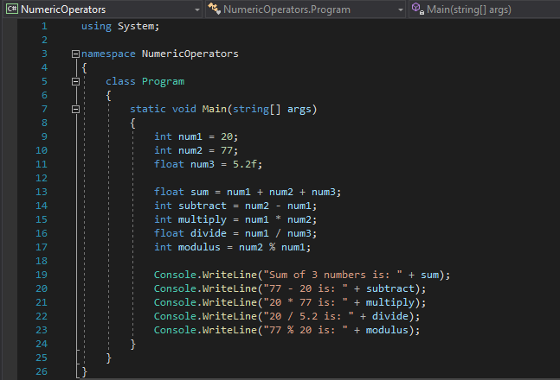

2) Run your program, you should see:

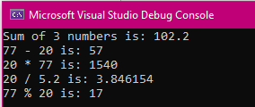

**Challenge 1: Explain the code above by commenting the code**

**Part II: Routines**

**Create a project**

1)Open Visual Studio.

2)File > New > Project

3)Select Console App (.NET Core), click Next

1. 4)Type “Increment-Decrement” in the Project name and save it in the Module 3 of repository you cloned from week 1, it should be similar to below:

CS132/HOP-hands-on-practice-YourGitHubUserName/Module3

Operators are used to perform operations on variables and values.

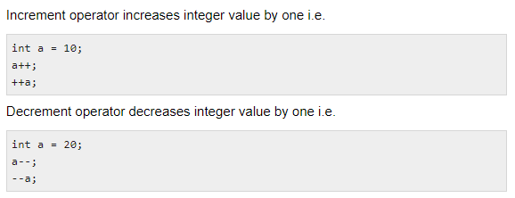

Let’s go back to the for loop we have learned in Week 2’s HOP:

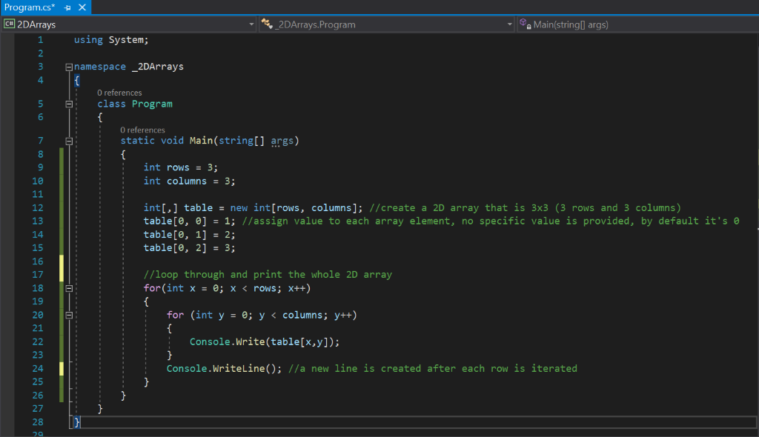

Interger x and y start to be counted from 0, and incremented by each time the for loop is read. Until x is equal to rows (3) and y is equal to columns (3), the for loop is completed. Now, let’s try to use a for loop again to understand it better.

Let's practice!

1) Type the following code in your Program.cs

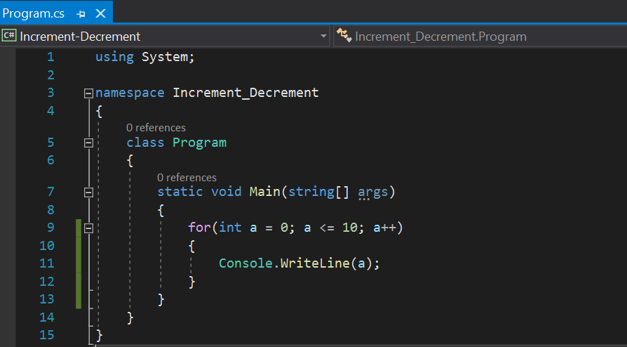

2) Run the program, you should see:

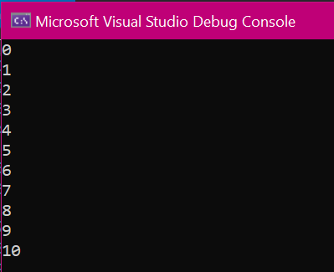

**Challenge 2: Explain the code above by commenting the code.**

**Challenge 3: Use a for loop to print out 15 to 1. Expected result:**

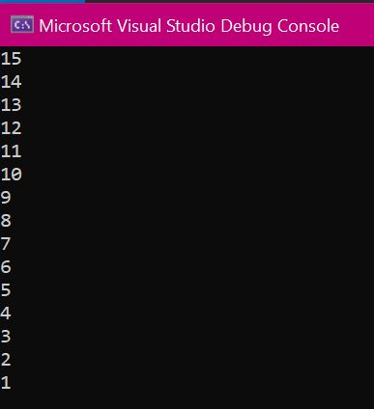

**Push your work to GitHub**

Once you completed the Hands-on practice, do the following to push your work to GitHub

Go back to the Terminal (for Mac users) or Command Prompt (for Windows users), make sure you are in the right path, for example: KimNguyen/Desktop/CS132/CS132-HOP-Hands-On-Practice-KimNguyenMai/Module 3

Type the following command:

>>> git add . (to copy all changes you have made)

>>> git commit -m “Submission for Module 3 – YOUR NAME” (To add a message to your submission)

>>> git push origin master (to upload your work to Github)